**Materials and Methods**

* Fig 1. – for each measured valued used $\left(x-mean\right)/sd$ where the mean and standard deviation for each pollutant were calculated for all sample points and dates together.
* Fig 2. For each sampling point, distance from head of channel along the line was calculated, as well as elevation from DEM (masl). The points were divided based upon the typical slope and each region. Upstream +eriosion, midstream erosion/sedimentation, downstream: sedimentation.
* Meteorological Data from Neve Yaar [NY-MA] meteorological station which is operated by the Ministry of Agriculture from 2017 and includes 10-minute precipitation data that was used for this study. An additional station nearby is also named Neve Yaar [NY-IMS], but operated by the Israel Meteorological station and it also collects 10-minute precipitation data beginning 2005 (See Map 1).
* In order to calculate SPI we need historical rain data for multiple years. Although NY-MA’s rain data is more reliable, it operates less years thus containging less data. In order to compile historical rain data for NY-MA, the NY-IMS was used as reference.
* This was done by comparing existing parallel rain data from both stations using a linear regression (OLS) (P-value-?). The resulting regression line was used to compute estimated historical rain data that was collected only in NY-MA, beginning in 2005.
* SPI – Calculates the total daily rain 2 days and 5 days prior to sampling date.   
  [https://climatedataguide.ucar.edu/climate-data/standardized-precipitation-index-spi] - ?????
* Group line, mean categorized by stream section and by SPI index

**Results and Discussion**

**Fig. 1 : Map**

**Fig. 2: Overall distance from mean heatmap**

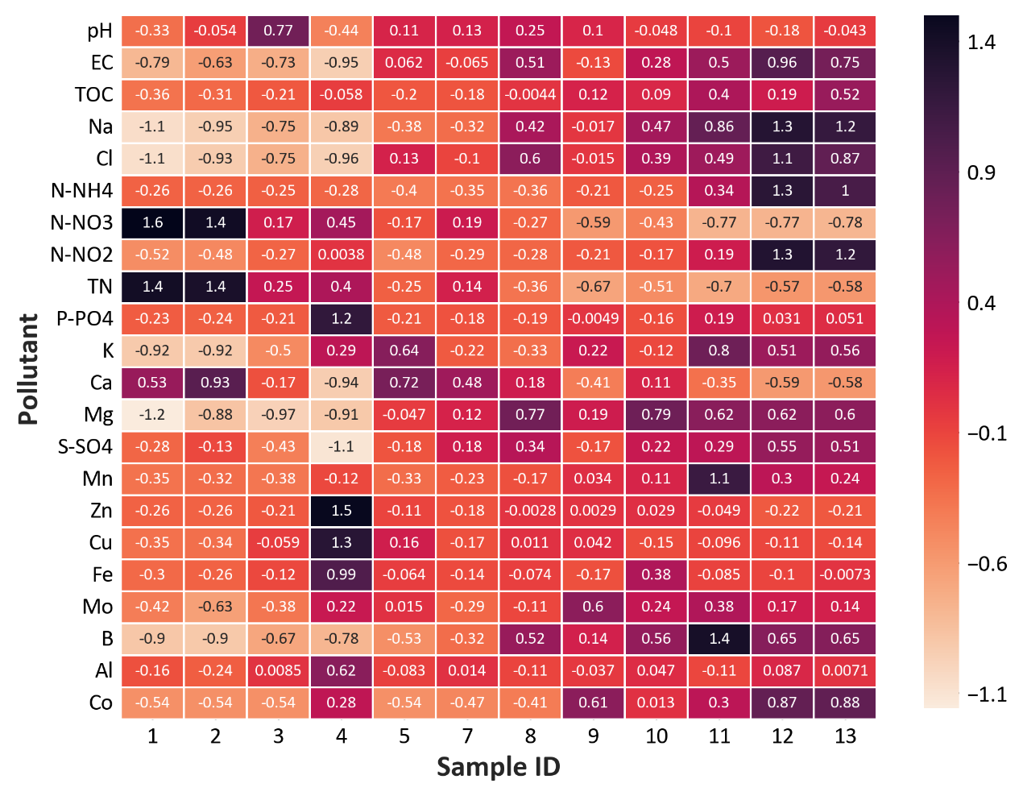

Fig . 1 **The distance in standard deviations from the overall mean (all points and times)**

High levels of Nitrogen (Nitrate) relatively low salinity (EC. Na and Cl) observed in first points.

Final two points (Kishon river) charchterized by hiugh salinity and Nirite

Specific points show unique pollution. Point 4 – high phosphorus, Zinc and Copper. This point was often charchterized in reddish water indicating a specific pollutant source.

Point 11, which is located ater a treatment plant prone to malfunctions, exhibits high Mangense and Boron,

Middle points show relatively average values.

**Fig 2**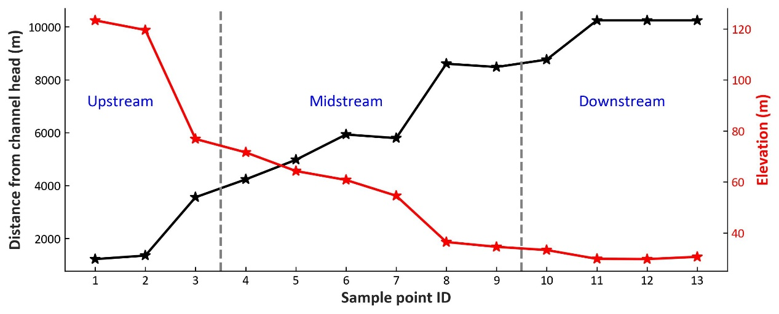

There

